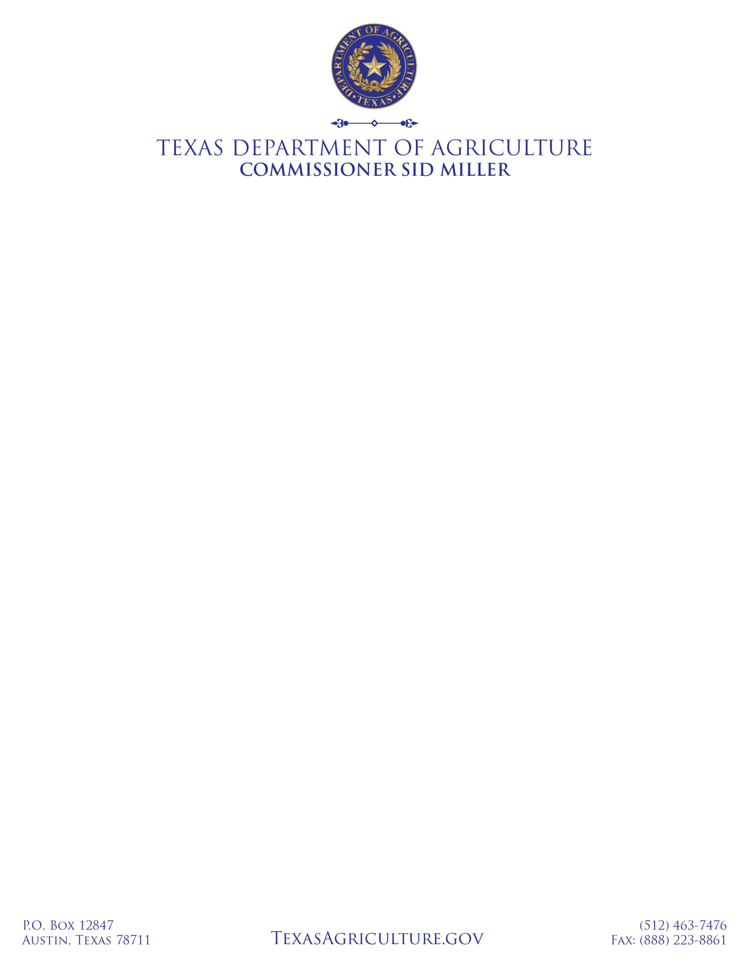

2023 Ag Pesticide Applicator and Course Provider Update

Beginning January 1, 2023, applicators will be required to obtain their required CEUs for their respective license classification for each licensing period. The Texas Department of Agriculture (TDA) will NOT be extending the exemption of agriculture Continuing Education Unit (CEU) requirements. Licensed applicators with expiring licenses or needing CEU’s will not be allowed to renew their license if they have not met their CEU requirement for their current licensing period.

COMMERCIAL, NON-COMMERCIAL AND NON-COMMERCIAL POLITICAL APPLICATORS
For licenses expiring in 2023: TDA will NOT exempt commercial, non-commercial and non-commercial political applicators who have taken online or correspondence courses within the last year. The TDA Rule 7.24 (t) (2) does not allow for online or correspondence courses to be taken 2 years consecutively. Commercial, non-commercial and non- commercial political pesticide applicators are required to obtain 5 CEUs per licensing period.

PRIVATE APPLICATORS
For licenses expiring in 2023: The TDA will NOT exempt private applicators from the TDA Rule 7.24 (v) (5). This rule does not allow a private applicator to acquire more than 10 CEUs through correspondence courses. Private applicators will no longer be allowed to acquire ALL of their CEUs through correspondence courses (online). Private applicators are required to obtain 15 CEUs per 5-year licensing period.

CEU COURSE PROVIDERS
For CEU course providers, live courses that have already received TDA approval may continue to be offered via- live web-based courses. These courses must have the capability for the audience to ask questions and/or interact with the speaker. Course providers are asked to notify TDA of interactive course dates so that applicators can attend available courses during this period. TDA will update their website with course dates. Course providers are asked to continue to offer courses and may submit new CEU courses for approval by emailing a completed PA-409 to recertcourses@TexasAgriculture.gov. The TDA requests that providers contact TDA prior to any course given via a live, web-based program (Zoom, Facebook Live, etc.) so that staff can monitor/participate in the course. All courses will be posted on the TDA website.

TESTING
Testing is currently offered by the TDA’s third party testing company, PSI, LLC. The testing centers have been modified to safely accommodate in person testing with Covid 19 safety protocols in place.

IMMEDIATE ASSISTANCE:
Perry Cervantes
Director for Environmental and Biosecurity Programs Perry.Cervantes@TexasAgriculture.gov
Cell Phone: (512) 955-9336

